Response to   
ASIC Consultation Paper 351  
Superannuation forecasts:  
 Update to relief and guidance

# Produced by mSmart

Questions and comments should be addressed to:

Dr Frank Ashe  
[frank@mSmart.com.au](mailto:frank@mSmart.com.au)  
0481 130 929

Superannuation forecasts

# Introduction

mSmart is a company that provides what, in the current document, are termed a superannuation forecast and retirement estimate. The calculator is available to the public at [www.mProjections.com.au](http://www.mProjections.com.au) and is operating under the current ASIC relief for superannuation forecasts.

We are continually upgrading the calculator to provide more analyses and to improve the analyses already provided.

There are areas of the industry where our knowledge is limited, in such a case we make no comment.

Questions and comments should be addressed to:

Dr Frank Ashe  
[frank@mSmart.com.au](mailto:frank@mSmart.com.au)  
0481 130 929

# Detailed Response

Heading numbers and descriptions are as in Consultation Paper 351. We reproduce these to make this document stand-alone.

We use the term *superannuation calculator* to include the calculators that support the *retirement estimates*.

## B Proposed update to relief for superannuation forecasts

B1 We propose to continue to provide relief from the licensing, conduct and disclosure obligations relating to personal advice for providers of superannuation forecasts by making a new single legislative instrument that covers both superannuation calculators and retirement estimates. As is currently the case, our relief for superannuation calculators will remain available to all providers, and the relief for retirement estimates will be available only to trustees.

We consider that the difference between a superannuation forecast and a retirement estimate is somewhat artificial. The retirement estimate is a superannuation forecast where information is obtained by the person providing the superannuation forecast from their records.

If a provider makes both estimates available then there should only be one calculator used. Consequently, we support a new single legislative instrument that covers both superannuation forecasts and retirement estimates.

Hence, ASIC should provide relief for all providers of superannuation forecasts subject to the requirements that are discussed in the answers to later questions. We believe this is essential to promote a continued improvement in the provision of calculators to superannuation fund members, from SMSFs to large industry funds..

B1Q1 Should ASIC continue to offer relief to trustees and other providers for superannuation calculators? Why or why not?

Yes, to promote continued improvement.

B1Q2 Should ASIC continue to offer relief for trustees to provide retirement estimates to their members? Why or why not?

Yes, to promote continued improvement.

B1Q3 Are there elements of the current relief for superannuation calculators or retirement estimates that discourage or prevent the provision of these tools by trustees?

No.

B1Q4 How are superannuation calculators and retirement estimates currently being provided by industry under ASIC’s current relief?

There are a number of providers of superannuation estimates, for instance we provide a superannuation calculator that is publicly available to all, under the relief provided by ASIC.

B1Q5 Are superannuation calculators or retirement estimates being provided without relying upon the current relief? If so, why are providers choosing not to rely on the relief?

No comment.

B1Q6 Are our proposed changes to RG 229 easy to understand? Is the structure and format of the regulatory guide helpful, or would a different approach be preferable? If so, why?

We believe that the proposed changes are easy to understand.

Different audiences have different preferences for how they receive information, so we suggest that as well as the formal guideline, necessary for legal purposes, other ways of communicating the guidelines are explored.

B2 We propose to remove the relief for superannuation calculators in ASIC Instrument 2016/207 and include it in the new legislative instrument for superannuation forecasts.

B2Q1 Do you agree that our relief for superannuation calculators and retirement estimates should be combined into a single legislative instrument? If not, why not?

Yes, see comments above.

B2Q2 Should ASIC continue to provide relief for financial calculators relating to retirement savings account (RSA) products, in addition to superannuation calculators? Why or why not?

Yes. A financial calculator that can do superannuation calculations should be able to handle the calculations necessary for retirement savings accounts. ***If it cannot do this then there are fundamental problems with the calculator that is being used.***

B3 Instead of mandating specific standardised text, as is currently required in [CO 11/1227] for retirement estimates, we propose that the disclosure requirements for both superannuation calculators and retirement estimates be principles based and require providers to clearly and prominently state:

(a) the purpose and limitations of the calculator or estimate;

(b) the impact of any significant limitations of the calculator or estimate;

(c) the assumptions;

(d) for an amount payable or accruing at a future time of two or more years, the present value of the calculation or estimate;

(e) that the calculator or estimate is not intended to be relied on for the purposes of making a decision in the absence of advice; and

(f) why the provider considers the default assumptions to be reasonable for the purposes of working out the calculation or estimate.

B3Q1 Do you agree with our proposal for principles-based disclosure requirements? Why or why not? Should there be any conditions or other steps taken to address particular risks arising from a principles-based approach?

We expect that there will be a continuing improvement in superannuation calculators, which means that there could be a problem of having mandated specific standardised texts.

We agree with five of the six points that have been raised as requirements. We do not agree with provision (e) that a statement needs to be made that the calculator is not intended to be relied on for the purposes of making a decision in the absence of advice.

One of the major problems in Australia’s financial advice industry is its excessive costs for many individuals. ***The provision of easily available calculators that can present the effects of different decisions made by the investor can reduce substantially the cost of helping an individual investor obtain a portfolio of assets that they are more comfortable will provide the retirement outcome that they wish, taking into account the risks that inevitably adhere to any decisions that are made.***

We agree that there should be no promotion of a specific product, or a specific investment management process that entails fees being provided to the investment manager.

If the superannuation calculator is doing its job and properly showing the results of different possible decisions, then people such as SMSF trustees should not be told that the calculator is not intended to be relied on for the purposes of making the decision. This will dissuade some from taking decisions that may benefit them, or will persuade others to incur unnecessary by seeing an advisor who provides no better input.

We propose that the providers should state that there are factors that are not accounted for in the calculations that should be considered, and that advice could be taken from a licenced advisor.

Advisers will be using this same calculator to help the SMSF trustee make decisions. Anecdotally, we have met many advisors who have a fundamental misunderstanding of the tool they are using. Many SMSF trustees may have a better decision-making process as a result of using a superannuation calculator than an advisor.

Putting in a text that says the calculator is not intended to be relied on for the purposes of making a decision reduces the comfort that SMSF trustees would have that the calculator is doing its job properly.

## Limitations of the calculator

it is important in providing estimates of various future amounts, such as the size of a superannuation fund at the date of retirement or the possible level of spending that may be maintained in retirement, that the high level of uncertainty in these values be declared to the user. A single value such as the expected amount of superannuation at retirement or the expected number of years in retirement that a particular spending level may be maintained is not appropriate.

The full uncertainty of these outcomes needs to be stressed to the user so that appropriate trade-offs between risk and return can be considered when making decisions.

The question of how to best present the degree of uncertainty in future estimates is an open one. There has been much analysis and research by academics and market practitioners in a wide range of areas, apart from the purely financial side of the industry, for instance in the presentation of risks of new vaccines, or significant technologies. A good summary of the literature is available in (Fischhoff, 2012)

There is no single solution that has been found, and it is very unlikely that it will be. But the uncertainty does need to be presented.

We provide a PDF document of one of our reports that shows our approach to the problem. To keep this document stand-alone we show two extracts here.

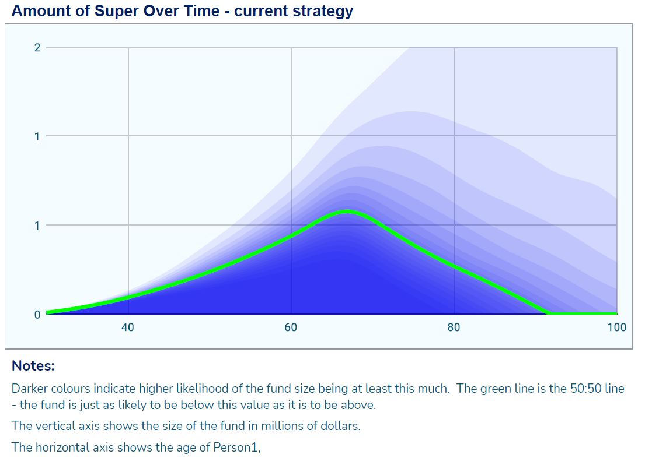

B3Q2 Should we prescribe how specific assumptions should be disclosed (e.g. insurance premiums)?

The difficulty with prescription of how specific assumptions should be disclosed is that the industry can be changing very quickly in certain areas.

We would recommend that prescription on specific assumptions disclosure should be kept at a general level while requiring that all significant assumptions are presented to the user of the calculator.

B3Q3 Are there any specific changes we should make to our relief or guidance on presentation or disclosure that would encourage trustees to provide superannuation calculators or retirement estimates?

No comment.

B4 We propose to:

(a) in our relief, retain a requirement that superannuation calculators must not be used to advertise or promote a specific financial product, and introduce a requirement that retirement estimates must not advertise or promote a specific product; and

(b) provide guidance on how assumptions relating to a specific financial product can be used without breaching the requirement not to advertise or promote a specific financial product: see draft RG 000.93–RG 000.96.

B4Q1 Do our proposed changes to the relief and guidance give sufficient clarity about how a superannuation calculator or retirement estimate may be given without advertising or promoting a specific financial product? If not, why not?

We believe that sufficient clarity is given.

There are some investment products that do not fit within the standard product categories and may only be offered by one provider. It would stifle innovation if those product providers were not able to forecast superannuation outcomes that reflected those particular products’ characteristics. An example is some form of dynamic asset allocation to replicate the payoff of a put option on an asset class or a whole portfolio.

The product providers should be required to give full information on the assumptions and any new methodologies that allow their product to be incorporated into the superannuation calculator.

B4Q2 Are there other ways to reduce the risk of a member assuming the forecast can be relied on to make a decision about a specific financial product?

Descriptions of calculator outcomes need to be presented as factual, without any language that could be interpreted as a recommendation.

There are subtle ways that results can be expressed that are actually recommendations. For instance, some calculators present a portfolio as being “optimal” given the inputs. The use of the term “optimal” is not warranted, as the portfolios are only optimal under very strict assumptions that are never met in practice. However, “optimal” is a word that has positive connotations in the minds of most readers and will unconsciously bias the readers into preferring the “optimal” solution.

The use of such value-laden terms should not be allowed.

B5 We propose to retain the requirement that retirement estimates may only be given to members aged under 67 who have been a member of the fund for the year ending on the date of the estimate. We propose to additionally require in the relief instrument that a retirement estimate must not be given to a member who:

(a) is in the retirement phase at the date of the estimate;

(b) has not made or received a contribution to their account during the year ending on the date of the estimate;

(c) has an account balance of less than $6,000 at the date of the estimate; or

(d) has a defined benefit interest in the fund.

B5Q1 Do you agree with the proposed restrictions on who may be provided with a retirement estimate? Why or why not?

We agree with points (b), (c) and (d). We disagree with point (a).

We believe that members who are in the retirement phase as at the date of the retirement estimate should be able to have an estimate of the future income stream that may be available to them as market conditions may have changed significantly since the last retirement estimate.

The superannuation calculator providing the estimate should be able to handle members in the retirement phase. It is essential that members can see the effect of different asset allocations for example on their retirement incomes so that they can make reasonable decisions as to the suitability of their current investments.

B5Q2 How do trustees currently decide which members to give retirement estimates to? For example, are members selected on the basis of age, current balance, contributions history or other factors?

No comment.

B5Q3 Are there other types of members that should be included or excluded from the scope of our relief for retirement estimates? Why or why not?

No comment.

B6 We propose to allow trustees to deliver retirement estimates through member online portals, as well as through periodic statements. We will amend our guidance to clarify that retirement estimates can be provided to members more frequently than through periodic statements. We will also clarify in our guidance that a retirement estimate may be given in video or audio format provided the requirements of our relief are met (e.g. in relation to disclosure).

B6Q1 Are there practical limitations to trustees providing retirement estimates more frequently than in periodic statements?

There should be no problem in providing estimates more frequently than periodic statements. In fact, we would suggest that funds provide online calculators for their members that can be accessed at any time.

We would also suggest that information regarding member balance and fees should be available to members in a computer readable form that can then be input to calculators that are independent of the fund.

Technologies that make this simple for users are already available. See [www.idexchange.me](http://www.idexchange.me) for an example.

B6Q2 Does draft ASIC Instrument 2022/XXX appropriately facilitate the provision of retirement estimates to members through an online portal? Would further ASIC relief or guidance help trustees deliver estimates in this way?

No comment

B6Q3 What are the risks in allowing trustees to deliver retirement estimates to members through an online portal?

The most significant risks in this instance would be that members enquire concerning their retirement estimates far too frequently. This would be especially the case in a period of market turbulence. Unfortunately, we know that a significant subset of members would be tempted in a time of market decline to move their investment funds into cash or a similar instrument.

B6Q4 What are the risks in allowing trustees to deliver retirement estimates to members in video or audio format?

Video or audio format allow information to be presented in a more member friendly manner than bare text. However, the presentation of numerical data is sometimes best done by printed form that can be more easily re-read than watching a video repeat.

This is a rapidly growing area and we would not like to see too many restrictions that could hamper a significant increase in member engagement.

We would suggest that information provided in a video or audio format should also be automatically provided in a text and graphical format.

B7 We propose to explicitly allow for interactive retirement estimates in our relief and guidance. An interactive retirement estimate is a retirement estimate delivered through an electronic facility or device that is worked out using data a trustee holds on a member, but where the member can also interact with the estimate by changing the assumptions.

B7Q1 Do trustees already provide interactive forms of retirement estimates? If so, how are these provided to members?

No comment.

B7Q2 Are these interactive estimates provided by relying on ASIC’s current relief? How are the default assumptions set?

No comment on the provision of interactive estimates.

The default assumptions for the retirement estimates should be exactly the same as the default assumptions for the superannuation calculations.

B8 We propose that the single legislative instrument would expire after a set period of time.

B8Q1 What is the appropriate period of time for the relief, given the need for trustees and other providers to have certainty about the regulatory settings to make use of the relief?

We believe that a period of three years would be acceptable.

B8Q2 How do superannuation calculators and retirement estimates currently influence member behaviour? What data and evidence do trustees and other providers currently collect on how these forecasts, including their assumptions and presentation, influence member behaviour and outcomes?

No comment.

B8Q3 What reliable and robust data and evidence can trustees and other providers collect on how their superannuation calculators or retirement estimates influence their members’ behaviour or outcomes?

The collection of reliable and robust data is incompatible with privacy issues. Ideally, we would like to see a connection between a person accessing an online superannuation calculator or retirement estimate and subsequently making a change to their investment asset allocation. This is too intrusive.

However, there are sets of anonymized data that can be collected and made available for analysis. For instance, in a superannuation calculator there is information required to be input on fund size current age, expected age of retirement, and many other pieces of data. Collecting such information over time would allow comparisons of areas of interest of members and economic or market behaviour at that same period of time. Movements by members of fund accounts that follow an uptick of interest in superannuation calculators would be one of many interesting observation that may lead to better engagement of members and better member outcomes.

The ability of A/B analysis for online calculators and digital interaction with members enables funds and other calculator providers with the mechanisms to measure and potentially enhance the engagement with users.

B9 We propose a six-month transition period for the new requirements.

B9Q1 Do you agree that a transition period of six months is appropriate for providers to comply with the proposed relief (i.e. by 1 October 2022, assuming the new instrument is made on 1 April 2022)? If not, do you consider a longer or shorter period is required?

We believe a six-month period is appropriate.

B9Q2 Are there any unintended consequences of the proposed relief that would affect implementation by industry?

We do not see any unintended consequences of the proposed relief.

B9Q3 Will it be practical for trustees to provide retirement estimates under the proposed relief as part of, or alongside, periodic statements for 2021–22?

If trustees are already providing estimates then there should be no problem providing estimates under the proposed relief.

If trustees are not providing estimates and wish to start providing them under the proposed relief then there are third-party providers, including ourselves, who would be happy to help them meet such a requirement.

B10 We also plan to update ASIC’s Moneysmart superannuation and retirement calculators during the transition period to align with the framework under the single legislative instrument.

B10Q1 What impact (if any) will our plans to update the default assumptions in our calculators have on trustees or other providers who choose to use the same assumptions?

There should be no impact on updating default assumptions in any calculator that is currently in use. If there is a significant impact then the calculator is very badly designed and should be retired immediately.

B11 We propose to remove the no-action position for retirement estimates outlined in RG 229.

B11Q1 Is the no-action position necessary for trustees to feel comfortable providing retirement estimates? If so, why?

No comment.

B11Q2 Under our proposed relief, what concern (if any) would a no-action position seek to address?

No comment.

C1 We propose to adopt a single framework for how economic and financial assumptions should be made for superannuation calculators and retirement estimates when relying on our proposed relief. We will apply this framework through the new relief instrument. We will update our guidance on how ASIC intends our relief to apply.

C2 Under this framework, we propose to give trustees and other providers flexibility to set their own reasonable assumptions relating to investment earnings, fees and costs for superannuation products. These assumptions must be reasonable and certain disclosure requirements must be met: see draft RG 000.116–RG 000.128.

C2Q1 Do you support trustees and other providers having flexibility to set their own reasonable assumptions for investment earnings, fees and costs, including on the basis of the product a member is invested in? Why or why not?

In the interests of providing comparability between superannuation calculators it is important that a standard set of assumptions be used by all calculators. Calculators would then be able to produce a new set of results on assumptions that the calculator provider believes are more reasonable than those default assumptions. The full rationale for those beliefs needs to be simply accessible by the user of the calculator.

The results using default calculations should be given first. The format of the presentation should be left to the provider of the calculator.

The range of reasonable returns for different asset classes can be quite considerable. The paper by Damodaran (Damodaran, 2021) shows the uncertainty in one of the most basic parameters that needs to be put into a calculator i.e. the equity risk premium (ERP). The equity risk premium is the expected difference in return between the equity market and the long-term bond market. A typical figure would be around 4 to 5% however 3% to 6% would also be defensible values.

Estimates of long-term bond returns are themselves subject to a high degree of uncertainty. A significant component of the estimate of a long-term bond return is the return of inflation. If we are to have significant inflation, let’s say a 4%, in the long-term then we will see long-term bond yields above 4%. In the short term, the return on long-term bonds will be negative as an increase in yield implies a decrease in price.

The difference between the inflation rate and the long-term bond yield depends itself on the level of inflation. The higher the level of inflation, the higher the difference between the bond yield and the inflation rate. In the interests of allowing the evolution of better calculators the freedom allowed to the calculator provider to set their own reasonable assumptions is essential.

## Basic methodologies

The common methodology used by Moneysmart and many superannuation calculators is to assume a long-term return that is applied over all years in the future. In stochastic models this is usually the expected return for which the calculator allows a stochastic measure to be used, in which case the expected long-term return is the statistical expectation for each year of projection.

But returns in the short-term and medium term future can be very different from the long-term. Taking interest rates for example, the current short-term interest rate is close to 0%, which we expect to increase to some higher value such as to 3% or 4% in the medium to long-term. If a member is close to retirement and has an investment strategy that intends to move to more interest rate assets after retirement then the assumption of a 3% short-term interest rate for all years, including the years to retirement, can give a misleading result.

In fact, there are a number of future scenarios that can be proposed for the long-term. We could see in environments where we have inflation of 3% with cash rates of around 5%. This could be contrasted with a long-term future where inflation is close to 0% and cash rates are very close to 0% as well. Both futures are possible but have different superannuation outcomes, even when expressed in present values.

If the economic scenarios that are used to drive the stochastic nature of future outcomes include regimes where low inflation can be followed by high inflation, and possibly even years of deflation, then the assumption of a uniform rate of expected return is not acceptable.

For stock markets the assumption of a uniform rate of return in the future is also problematical. Evidence, see (Arnott, et al., 2017) for example, shows that there may be periods of relatively low return in stock markets when equity valuations are high, and periods of relatively high returns when equity valuations are low.

This example shows expected 10 year real returns in USD for a variety of asset classes calculated by Research Affiliates, a well-regarded quantitative analysis firm. Note that their expected returns for US Large stocks is -1.0% per annum.

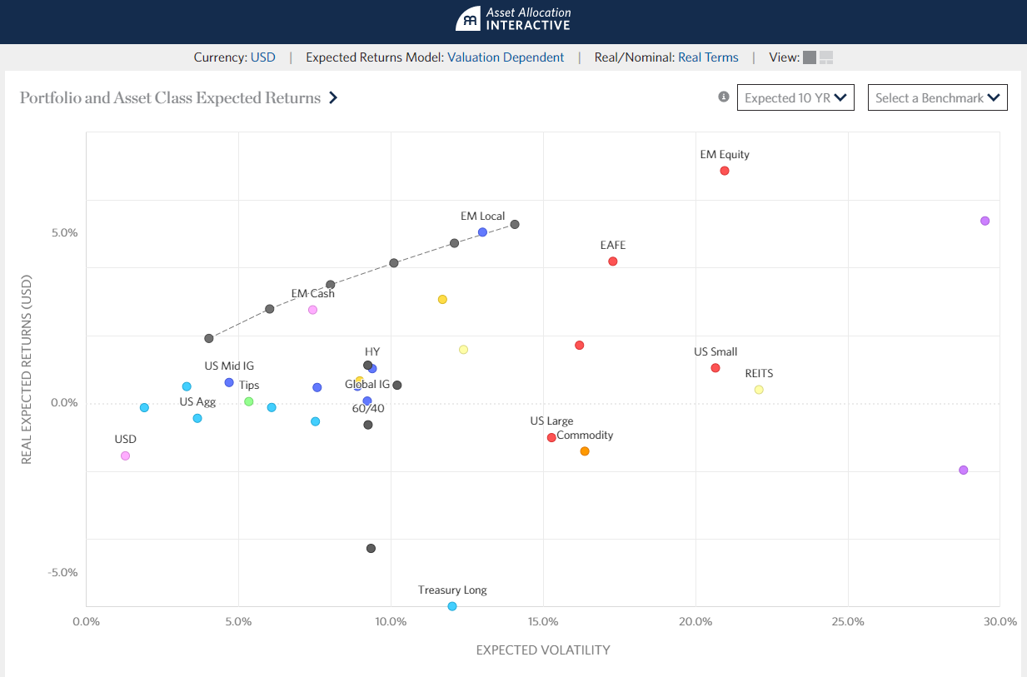

1 Source: https://interactive.researchaffiliates.com/asset-allocation#!/?currency=USD&model=ER&scale=LINEAR&terms=REAL

For a member aged in their 60s and approaching retirement, projecting long-term returns of 6% p.a. when the next 10 years might only be -1% p.a. is likely to be quite misleading.

C2Q2 What are the risks to members and to industry of trustees setting their own reasonable assumptions for investment earnings, fees and costs relating to the product in which a member is invested in, or a product which the trustee offers? How can these risks be mitigated?

The main risk to members, and to the industry itself, of trustees setting their own reasonable assumptions for various parameters, is overconfidence and optimism bias. These biases are well documented in the behavioural economics literature.

The effect would be for trustees or the superannuation calculator provider to be biased towards high values of investment returns and low values for fees and costs. This would give unrealistic expectations for the member.

C2Q3 Should trustees have greater flexibility to set other types of assumptions, either for a retirement estimate or superannuation calculator? Why or why not?

Providers of calculators should be able to set assumptions at any level that they can reasonably justify. The justification for moving from ASIC assumptions needs to be in an easily accessible form, such as in a white paper easily accessible on the providers website.

C3 We propose to prescribe some default assumptions relating to the retirement age, drawdown period and inflation rates to foster consistency and comparability across providers. These requirements would apply to both superannuation calculators and retirement estimates. Some additional requirements would also apply to retirement estimates in working out the annual income stream and the use of member data: see draft RG 000.129–RG 000.168.

We mostly agree with the currently proposed default assumptions given in the draft regulatory guidance.

One area where more discussion may be warranted is in the rates of inflation. Two are proposed, one of 4% per annum to be used up to retirement age, and the second of 2 ½% after retirement. We understand the rationale of this is that members will be receiving salaries that will be going up at a rate of 4% before retirement. The assumption is that real wages will be 1½% p.a. above inflation and users will make an hedonic adjustment to these increases, while after retirement their hedonic adjustment will be based on the inflation rate, which is used for the increase in the Commonwealth aged pension.

We agree with the principle that results should be reported in present values. And that some adjustment needs to be made for the reasonable expectations (or hedonic adjustments) that people may have on their future lifestyles. The proposed methodology has simplicity as its main good point.

When more complex models of inflation are used in the superannuation calculator, we would propose that the equivalent of present values could be based on adjustments that show future benefits as ratios of projected member salaries and/or consumer prices.

C3Q1 Is there evidence for how members understand or interpret differences in forecasts, either across types of forecast (superannuation calculators and retirement estimates) or across different trustees (or other providers of superannuation calculators)?

No comment.

C4 We propose to update our guidance to explain how trustees and other providers can set reasonable assumptions. We consider assumptions are likely to be reasonable if they are:

(a) backed by evidence or expert opinion;

(b) not intentionally biased towards encouraging members to make a specific financial decision (e.g. by leading to a higher or lower forecast);

(c) kept up to date with government policy settings and expected changes to future economic and financial conditions; and

(d) internally consistent—that is, each assumption should be reasonable in the context of all the others: see draft RG 000.172–RG 000.185.

We also expect that providers will revise their assumptions at least every three years, or more frequently if there are material changes to a relevant input or statutory assumption, and take steps to limit the risk of providing a misleading forecast because assumptions are out of date: see draft RG 000.186–RG 000.190.

C4Q1 Do you agree with our explanation of when default assumptions are likely to be reasonable? Why or why not?

We believe that the explanation of when default assumptions are likely to be reasonable is adequate. Trying to make an explanation more explicit is likely to act as a deterrent to future improvements in calculators.

C4Q2 How frequently should providers be expected to revise the economic and financial assumptions they apply?

We would expect that providers of calculators would review their assumptions at least on an annual basis. This would be professionally prudent. That does not mean that they would necessarily revise their assumptions, but the review should be made.

When fully operational we expect that our calculator would be updated to reflect market conditions on a daily basis and long-term and medium-term projections would be reviewed on a quarterly basis.

C5 We propose to update our guidance to state that we expect trustees who provide both superannuation calculators and retirement estimates will set assumptions consistently across these forecasts. There should be reasonable grounds for using different assumptions (e.g. tailoring assumptions for a retirement estimate based on an individual member’s investment strategy): see draft RG 000.182–RG 000.183.

C5Q1 Should trustees be expected to set the same assumptions across all superannuation calculators and retirement estimates they provide? In what circumstances should assumptions be able to differ?

We believe that at a minimum when setting expected rates of return that two rates be given, one would be the rate for real assets, such as the stock market and real estate, and a second would be for returns that are related to interest rates, such as investment in government and corporate bonds.

These two rates can be turned into one rate by using the investment strategy of the member. This makes it necessary for superannuation calculators the user needs to be asked on the expected proportion of assets in the broad asset classes.

This would make it automatic for retirement estimates provided by a fund trustee to have different rates of return for different investment strategies.

The rates assumed for different asset classes should be the same whether we are using a superannuation calculator or making a retirement estimate.

C6 For superannuation calculators and retirement estimates, we propose to:

(a) give trustees (and other providers of superannuation calculators) the flexibility to set their own reasonable assumptions for investment earnings, fees and costs; and

(b) require that these assumptions be reasonable and that certain disclosure requirements are met.

This would allow trustees to set assumptions based on the product(s) an individual member is currently invested in (for retirement estimates) or on the types of product that the trustee offers (for superannuation calculators). We would update our guidance to explain how providers can set reasonable assumptions: see draft RG 000.116–RG 000.128.

C6Q1 What are the advantages and disadvantages of giving trustees and other providers flexibility to set their own reasonable default assumptions for investment earnings, fees and costs?

It is essential that superannuation members be able to set their own reasonable default assumptions for investment earnings. More sophisticated economic scenario generators give a range of values for different asset classes earnings. These can then be applied to the actual asset allocation of the individual investor. It is not only the expected earnings that should be allowed to be changed but also the volatility of those earnings in the future. For example, a concentrated investment holding should have a higher volatility of return than a more diversified investment holding and this needs to be taken into account when the uncertainty of future fund size and income stream is presented to the user.

C6Q2 Is there evidence that members may misunderstand forecasts that are based on specific superannuation products? If so, are there ways to reduce this risk? In what circumstances would differences across forecasts be misleading (e.g. by creating a sense of false precision)?

The evidence is that members may misunderstand forecasts no matter what is done. Trying to reduce the possibility of misunderstanding by members is a continuing task for all people in the communication business. It will never stop.

Variations on the methods that we described in section C5 are suitable for coming up with consistent forecasts across a range of superannuation products.

One particular danger that can occur, and from personal observation of one of the authors does occur in practice, is that trustees may give a higher rate of return for an asset class that they believe (in the sense of wishful thinking) will give that higher level of return. To use an example that is not that far from reality, ESG investing has been claimed to give a higher rate of return than non-ESG investments because of, supposedly, the better overall management of the company that implements ESG philosophy. The evidence for this is slight, but motivated thinking by trustees could lead them to giving an unjustifiably high rate of return for these assets which could lead to members switching to ESG funds. This may be done with the best of intentions, and completely without conscious deliberation, but could lead to excessive risk for the portfolio.

C6Q3 In working out a retirement estimate, would it be practical for trustee to set assumptions about investment earnings, fees and costs that may differ based on the products members are invested in? Why or why not? Are there alternative approaches?

Yes, see earlier comments.

C6Q4 What guidance should ASIC provide on how assumptions about investment earnings, fees and costs should be set? Would it be appropriate for trustees to set assumptions on the basis of existing investment return objectives for superannuation products they offer (e.g. the return objective disclosed in the Product Disclosure Statement (PDS) or set by the trustee board?)

The assumptions on investment earnings, fees, and costs should be consistent with the return objectives disclosed in the funds’ PDS.

Our experience in the industry gives us the expectation that this would be done. The trustee board would be seeking the advice of the investment managers for the return objectives of the superannuation products, and the same investment managers should be giving expected returns for the asset classes consistent with the advice on investment return objectives.

C7 For retirement estimates, we propose to require that trustees must set default assumptions about administration fees based on the administration fees paid by the member over the previous year. Trustees could make reasonable assumptions about how administration fees would change in future (e.g. due to inflation or any scheduled fee changes): see draft RG 000.124.

C7Q1 Would requiring trustees to make reasonable assumptions about administration fees based on the administration fees paid by the member over the previous year be workable in practice?

This should not be unworkable. Any difficulty in a fund doing this would be a red flag that internal procedures are not adequate.

C7Q2 Could members be misled if trustees use member specific assumptions for administration fees in working out a retirement estimate alongside generic assumptions for investment earnings and investment fees and costs? If so, how could the risk of misleading forecasts be minimised?

It is implicit in the methodology that we have discussed earlier that there should be no generic assumptions for investment earnings for all funds, but the generic assumptions should be on asset classes from which, using the investment strategy, we can derive the specific return. The investment fees and costs can be related to the investment strategy and so there should be no problem.

C7Q3 Should we allow or require trustees to set different default assumptions for administration fees in the accumulation and retirement phases when working out a retirement estimate? Why or why not?

If the fund has different administration fees in the accumulation and retirement phases then it is essential that different default assumptions used.

External providers of superannuation calculators should provide for different default assumptions.

C8 We propose to prescribe default assumptions for the retirement age (age 67) and drawdown period (25 years) that must be applied to superannuation calculators and retirement estimates: see draft RG 000.129–RG 000.132.

C8Q1 What are the advantages and disadvantages of prescribing a default retirement age and drawdown period for superannuation calculators and retirement estimates under our relief? Please include relevant evidence, where available, of:

(a) the extent to which prescribed assumptions would reduce the risk of members being confused or misled if they use one or more superannuation calculator or retirement estimate;

(b) the proportion of members that currently choose to input their own retirement age or drawdown period assumptions into superannuation calculators; and

(c) any differences in likely future retirement ages or drawdown periods across different superannuation funds’ memberships.

It is necessary to prescribe default retirement ages and drawdown periods superannuation calculators and retirement estimates so that likelihood of misunderstanding by users of these tools will be mitigated.

From our anecdotal observations one of the first things that people look at with the superannuation calculator is the effect of changing their retirement age. The retirement age may be able to be set at any age from say 45, and not restricted to a minimum retirement age of 55 or 57 as some calculators operate with.

C8Q2 Are there some types of superannuation calculator for which these assumptions would be inappropriate or irrelevant?

We do not know of a superannuation calculator for which these assumptions would be inappropriate or irrelevant. If such a calculator exists, we would be interested in seeing it.

C8Q3 Is age 67 (the age pension eligibility age) a reasonable assumption for the retirement age? Why or why not?

67 is a reasonable assumption for the retirement age as it is the age at which one can access Commonwealth aged pension.

C8Q4 Is 25 years a reasonable assumption for the duration of the retirement period? Why or why not?

There are a number of reasonable assumptions for the duration of the retirement. We would expect that the assumption should be longer than the expected lifespan, take into account the expected mortality improvements over the period, but not too long as this would decrease the amount that people could legitimately spend without fear of running out of money. Using 25 years is a reasonable compromise.

C9 For superannuation calculators, we do not propose setting prescriptive requirements about how providers should make assumptions about annual income streams or age pension benefits. However, these assumptions must be reasonable and a superannuation calculator must not be used to advertise or promote a specific financial product.

C9Q1 How do superannuation calculators show forecasts representing different types of retirement income products (such as account-based pensions and annuities) under ASIC’s current relief? How could ASIC’s proposed relief facilitate calculators for different types of retirement income product in a way that does not advertise or promote specific financial products?

The methodology that we currently use presumes that an amount (adjusted for inflation) is taken each year from an account based pension, that when combined with the age pension, is a constant amount. We show the probability of different income streams per annum lasting for 25 years from retirement age for a range of asset allocations. In our product examples are given:

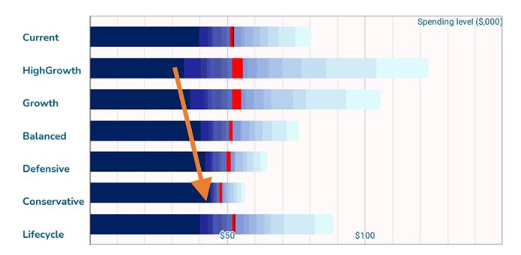

We anticipate providing annuity products to be included in the retirement phase but this would be a relatively generic process not taking into account any bells and whistles of a particular product.

Superannuation calculators should automatically include age pension benefits consistent with the fund size and income stream that are projected.

C10 For retirement estimates, we propose requiring trustees to work out the annual income stream on the basis that the member would have a constant income from year to year, after inflation, for 25 years. This includes drawing down their lump sum on retirement to zero and taking into account the minimum drawdown rules: see draft RG 000.133–RG 000.140.

C10Q1 For retirement estimates, what additional assumptions would need to be made to work out the annual income stream in the way that we propose? Should ASIC prescribe a specific formula? Why or why not?

Given the number of ways in which projections can be undertaken it would not be appropriate for ASIC to propose a specific formula.

In addition, it is difficult to see how a specific formula could be applied if the age pension is integrated into the annual income stream.

Using a specific formula would also not be able to show the uncertainty around the estimated annual income stream.

C11 For retirement estimates, we propose giving trustees the option to include age pension amounts in the annual income stream for a retirement estimate only if it is an interactive retirement estimate (i.e. delivered through an electronic facility or device that allows the member to make changes to the assumptions used to work out the retirement estimate). Trustees that do so would be required to apply prescribed default assumptions (e.g. about homeownership and partner status). Trustees would also need to work out annual income in a way that reflects how the member’s age pension entitlement may change as their retirement balance is drawn down: see draft RG 000.141–RG 000.149.

C11Q1 What are the advantages and disadvantages of allowing trustees to include age pension amounts in a retirement estimate only if it is an interactive retirement estimate that allow the member to make changes to the assumptions?

(a) What evidence is there for how numerical forecasts of age pension eligibility influence member behaviour? Does this vary depending on the magnitude or accuracy of the forecast?

(b) Would factual information alongside a static retirement estimate be more or less effective in raising member awareness of their potential age pension eligibility compared to a numerical forecast? Why or why not?

(c) Why do trustees currently choose to include, or not to include, age pension amounts in retirement estimates? Do trustees choose to include age pension amounts only for specific subsets of their members?

(d) Would trustees be less willing to provide retirement estimates to their members if they could not include age pension amounts in static estimates? If so, would trustees seek to provide interactive retirement estimates instead?

Interactive retirement estimate calculators are required so that members may customise the calculation to suit their current conditions. This includes their partner status, amounts that may be in other superannuation funds, other external investments, homeownership status, and whatever else may need customisation.

C11Q2 Should age pension amounts be required by default in interactive retirement estimates or in superannuation calculators? Why or why not?

Superannuation calculators and interactive retirement estimates should consider the age pension amounts as this may be an integral part of a member’s annual income. This is especially true for members who have had considerable breaks in their working life and or suffer from gender and minority based wage discrimination.

C12 For retirement estimates, we propose to make some changes to how trustees must make assumptions about a member’s superannuation contributions and insurance premiums. Specifically, we propose to:

(a) continue to require that trustees use the member’s contribution levels over the previous year (less insurance premiums, contribution taxes and any inward rollovers); and

(b) require that trustees assume this amount will change in line with legislated future changes in the rate of Superannuation Guarantee, as well as wage inflation.

Trustees could exclude any non-compulsory contributions a member has made in the previous year, where it is possible to do so and on the basis that the trustee discloses that these contributions have been excluded in working out the estimate: see draft RG 000.152–RG 000.156.

C12Q1 Are there other ways in which assumptions could be made about future superannuation contributions in working out retirement estimates (e.g. using a three-year rolling average)? To what extent would this better reflect how contribution levels may change over the long term for most members?

There is no perfect way in which assumptions can be made in this situation. The process that ASIC has proposed is reasonable.

C13 For retirement estimates, we propose to continue to require that insurance premiums paid by the member in the previous year be deducted from the amount of superannuation contributions. However, insurance premiums must not be deducted if the member does not have insurance at the time the retirement estimate is made: see draft RG 000.157–RG 000.160.

C13Q1 Are there other ways in which future insurance premiums could be taken into account in working out retirement estimates?

There is no perfect way in which assumptions can be made in this situation. The process that ASIC has proposed is reasonable.

C14 We propose to set standardised default inflation rates that must be used when showing the present value of a retirement estimate or the output of a superannuation calculator. These rates would reflect growth in wages (wage inflation) during the accumulation phase and growth in consumer prices (price inflation) during the retirement phase: see draft RG 000.163–RG 000.168.

C14Q1 What are the advantages and disadvantages of ASIC setting standardised default inflation rates for both superannuation calculators and retirement estimates? Please include relevant evidence, where available, of:

(a) the extent to which common assumptions would increase or reduce the risk of members being confused or misled;

(b) the proportion of members that currently choose to input their own inflation rate assumption into superannuation calculators; and

(c) any differences in forecasts of long-term price or wage inflation across different superannuation funds’ memberships.

It is essential that, as much is possible, future dollar values are expressed in present values. There is ample evidence that members can be confused and misled by quoting inflated values for income and fund size.

However, there is no perfect way in which we can bring the future values back to present values. This adds to the inevitable uncertainty of the figures that we do show. We should not downplay the uncertainty of the figures that we are providing. Users of superannuation calculators need to be aware of these uncertainties.

C14Q2 What are the most appropriate types of inflation rate to apply to the accumulation and retirement phases?

Because there is no perfect way in which we can bring future values back to the present value there is no “most appropriate” type of inflation rate to apply.

One could argue that wage inflation rates should be used as discount rates for all periods of time, as in the retirement phase discounting at 2 ½% implies that pensioners are getting comparatively worse off compared to the two workers over time.

One could also propose that the typical inflation rate should be used to discount all periods as future wage inflation above the rate of ordinary inflation leads to a higher rate of living above the current conditions. Shouldn’t this be shown to users of superannuation calculators? There is no simple answer.

It could also be suggested that rather than using the Consumer Price Index estimates during the retirement, a price index more suitable for those in retirement should be used. The Australian bureau of statistics provides a number of these (Australian Bureau of Statistics, 2021).

To make things even more confusing, perhaps we should use something like the cost of thriving index proposed by (Cass, 2020), "an economic analysis that sought to understand whether a changing wage left a worker more able or less able to cover an average middle-class family’s needs”. Other groups of people could be easily substituted. This strikes us as a better tool, but one that is not currently available.

C15 In prescribing the specific rates that providers must apply, we propose to use Treasury estimates of long-term nominal wage growth (4.0% p.a.) for the accumulation phase as set out in the 2021 Intergenerational report. We propose to use the mid-point of the Reserve Bank of Australia’s inflation target (2.5% p.a.) as an estimate of long-term price inflation for the retirement phase.

C15Q1 How should ASIC set values for the default inflation rates, and how frequently should these rates be reviewed?

These values are suitable for default values. However calculator providers should not be constrained in their methodological approach to modelling inflation.

# References

**Arnott, Rob, Chow, Tzee and Chaves, Denis. 2017.** King of the Mountain: The Shiller P/E and Macroeconomic Conditions. [Online] researchaffiliates.com, October 2017. [Cited: 27 January 2022.] https://www.researchaffiliates.com/publications/journal-papers/374-king-of-the-mountain-the-shiller-pe-and-macroeconomic-conditions.

**Australian Bureau of Statistics. 2021.** *Selected Living Cost Indexes, Australia.* 2021.

**Cass, Oren. 2020.** *The Cost-of-Thriving Index: Reevaluating the Prosperity of the American Family.* s.l. : Manhattan Institute, 2020. p. 22.

**Damodaran, Aswath. 2021.** *Equity Risk Premiums (ERP): Determinants, Estimation, and Implications – The 2021 Edition.* March 2021.

**Fischhoff, Baruch. 2012.** *Risk Analysis and Human Behavior.* s.l. : Earthscan, 2012. p. 418.